Project Report
On

Exploratory Data Analysis of the Water Management Situation in Chennai
For the Course
Data Visualization
CSE3020

Submitted By
Aditi Aravind (17BMD0050)
Aryan Jain (17BCE0914)

Under the Supervision of
Prof Annapurna Jonnalagadda
Associate Professor Sr. , Scope
Vellore Institute of Technology, Vellore



PROBLEM STATEMENT
The Water Crisis of Chennai this year was disastrous at an unprecedented level.
Chennai is entirely dependent on ground water resources and rainfall to meet its water needs. There are four reservoirs in the city, namely, Red Hills, Cholavaram, Poondi and Chembarambakkam, with a combined capacity of 11,057 mcft. These are the major sources of freshwater for the city.
Apart from the reservoirs, the other sources of freshwater are desalination plants at Nemelli and Minjur; aquifers in Neyveli, Minjur and Panchetty; Cauvery water from Veeranam lake;

INTRODUCTION
Dried-out taps, shutting down of schools, restaurants and hotels running out of business, police protection for protecting water resources, water being transported by train and tankers. These are events taking place in our neighbourhoods.
This year, Chennai ran out of water. The Chennai metropolitan area (CMA) — consisting of Chennai city, with a population of 4.9 million, and its adjoining areas — has an estimated population of 8.6 million and is the fourth-largest urban conglomerate in India.
Chennai was in the news four years ago for an entirely opposite reason but an equally serious situation — the unprecedented floods of December 2015, that drowned the city for many days, devastating lives and impacting businesses.
This year, the reservoirs that overflowed during the 2015-16 floods, dried out. Of Chennai's total requirement of 830 MLD (million litres a day) water, the Chennai Metro Water Supply and Sewage Board(CMWSSB) was able to supply only about 525 MLD during the worst days of the crisis.
Post the 2015-16 season, the monsoon has been in deficit for two out of three years, with last year's monsoon deficit being ~ 40 per cent. On June 30, 2019, the combined storage stood at just 18 million cubic feet (mcft) (0.1 per cent of total storage of 11,257 mcft). Last year, on the same day, the storage was 2,245 mcft.

Significance
A comprehensive evaluation of the water situation in Chennai, taking into account past statistics and trends is crucial to make policies and implement action to ensure that the Chennai Water Crisis of 2019 does not repeat.
Visualization of the data allows for highlighting the most important factors that caused problems and makes identification of the problem and engineering solutions easier.
The need of the hour is to find optimal ways to conserve water so that it can be used throughout the year and not only during or after few months from monsoon.

Motivation
The Chennai Water Crisis was a harrowing scenario, and being a resident of Chennai since birth, it was a first-hand experience.
Seeing the plight of the people and the scope of optimization in the scenario, through this project we aim to use our skills and knowledge to document and analyse the present conditions and help prevent a future occurrence of such a situation

Objectives
- Visualize the water need / usage of the city
- Identify whether the water sources availability will be able to meet the needs till the subsequent monsoon?
- How bad is the current water crisis compared to previous years?

Scope and Application
This project aims to serve as an analytical document that includes the visualization of the past and current data, and also a prediction of future trends. This will provide a basis for further studies and implementing large-scale policies and legislations to ensure proper water management in the future.
LITERATURE SURVEY

- Work so far

- Science to Address India’s Water Crisis
Veena Srinivasan stated that India is one of the most water stressed countries in the world. However, despite appreciable increase in funding for water research, high quality science that is usable by stakeholders remains elusive. She attributed it to the absence of research on questions that actually matter to stakeholders, unwillingness to transcend disciplinary boundaries, and the demise of field-work research culture in favour of computer simulation.

- Demand and Supply of Water Resource in The State Of Tamil Nadu: A Descriptive Analysis-2012
DR.A.B.Angappapillai et al 1 (2012) analyzed, for India southwest monsoon is the main source of water that undergoes wide spatial and inter-annual variations related with global climate anomalies. In the coastal regions, the state receives more rainfall during north east monsoon. around 322 mm and 470 mm amount of rainfall is the normal rain that receives from south west and north east monsoon which is lower than the National normal rainfall of 1250 mm.

- Improved Water Management Strategies for Chennai Metropolitan Area
Radhakrishnan R et al 1 (2007) give the statistics for the demand and supply for water over the next couple of years, as visualized below. The statistics were forecasted by examining the domestic water supply and demand scenario of Chennai Metropolitan Area from the year 1981 up until the present date. It indicates that

- A Way Out of Drinking Water Crisis In Rural India (2013)
Suchismita Das et al 1 (2013) analyzed that over exploitation of ground water and receding water tables resulted in water crisis in many general and rural areas which resulting in dry wells, ponds etc. Pure and safe drinking water in rural area has taken demoralizing form. Because of no pure drinking water death zone arise and only sources of water are some natural springs and water pits kilometers away from their homes. Ground water is generally pure and safe for drinking but because of overexploitation, water table is progressively getting down. Due to high usage, the groundwater quality is being corrupted with pollutants such as heavy metals, pesticides, coliform, BOD, COD etc. Rain water storage tank which has a capacity of storing 10,000 liter have built after people have moved for rain water harvesting for drinking and managing water.
Rain water harvesting is used to recharge the underground water sources. This can be done with the common people’s participation, man-made scarcity and the looming water calamity can be overcome

- Water Management Issues in Chennai
S. Sethuram based on his analysis concluded that there are some key issues with the water management in Chennai, like poor water security. Based on his results he suggested that water supply is irregular, unreliable and inadequate. He accredited this to accessibility issues in certain areas. Demand management is lacking as the major project focus of policies is on supply improvement. While Rainwater harvesting does exist, the current demand management programs are insufficient to support Chennai’s population growth, management through conservation and efficiency needs further enhancement and dynamic action. He suggested that Chennai needs an enhanced control of project management, planning, as there are several supply implementations, out of which two major failures, recorded during his data collection, few interview responses and survey results were contradictory to the fact that there is a water security issue that hampers water supply management in Chennai.

- Status of Groundwater at Chennai City
Durai Loganathan et al[3] state that groundwater is the ultimate, most suitable fresh water resource with nearly balanced concentration of the salts for human consumption. But over burden by means of population pressure, unplanned urbanization, unrestricted exploration policies and dumping of the polluted water at inappropriate place enhance the infiltration of harmful compounds to the groundwater. There are several states in India where more than 90% populations are dependent on groundwater for drinking and other purpose. It was concluded that in the groundwater of North and South Chennai the water quality was within the ISI standard except the few parameters this may due to the intrusion of sea water, industrial effluents intrusion into the groundwater and improper maintenance of the sewage system. Hence, there is a need for groundwater treatment before it is used for consumption.

- Gaps identified

The initial dataset that we used had a break in data from 2002 to 2004, forcing us to change the datasets. The ground water datasets available are either expensive or very specific and not elaborate.

- Drive to do work

Through our work we aim to provide a basis for future work as well as extract various data and show it visually so that more people are aware about the problem and future research may be accelerated observing the trends in the data that we find.

Fundamental Concepts
- Data Cleaning and Pre-processing
- Data analysis, with Pandas and Numpy
- Statistical Methods – Regression and Correlation
- Deducing non-linear relationships
- Time Series Analyses
- Logical Analyses
- Data viz using Plotly and other tools
- Interpretation with respect to known facts

IMPLEMENTATION

Flow Chart:

Algorithm to Predict Level in 4th Dam
- Load the data into Dataframes and remove NaN values and irregularities
- Shuffle the dataset
- Divide into Input and output
  - Input being the first three dams
  - Output being the fourth dam
- Apply a Sequential Model
  - Sequential Model with 3 layers
  - First Layer – Fully Connected, 16 Units, takes inputs as the original input data.
  - Second Layer – Fully connected with 8 units
  - Third Layer – Fully Connected with 1 unit which gives the output.
- Fit the data to the architecture of the model created
- Calculate the mean absolute error and the mean squared error
- Display the outputs

Code:

1. Initial Exploratory Analysis
- Viewing the dataset using Plotly
from __future__ import division, print_function
import pandas as pd
import numpy as np
import scipy.signal as sg
import plotly as py
import plotly.graph_objs as go
import scipy.integrate as si
import matplotlib.pyplot as plt
import seaborn as sns
import matplotlib.pyplot as plt
from scipy.stats import norm

from plotly import tools
from sklearn.preprocessing import normalize

py.offline.init_notebook_mode(connected=True)
from ipywidgets import widgets

file1 = r'C:\Users\Aditi\Google Drive\College\Year 3\Fall sem\G2 DV\Project\Data\chennai_reservoir_levels.csv'
file2 = r'C:\Users\Aditi\Google Drive\College\Year 3\Fall sem\G2 DV\Project\Data\chennai_reservoir_rainfall.csv'

res_levels = pd.read_csv(file1)
rainfall = pd.read_csv(file2)
res_levels.tail()

layout = go.Layout(title = 'Reservoir levels',xaxis = dict(title='Time'), yaxis = dict(title='Total Amount Water in mcft'))

data=[]

for i in ['POONDI', 'CHOLAVARAM', 'REDHILLS', 'CHEMBARAMBAKKAM']:
trace = go.Scatter(
x = res_levels.Date,
y = res_levels.loc[:,i],
name = i,
mode = 'lines'
)
data.append(trace)

fig = go.Figure(data = data, layout = layout)
py.offline.iplot(fig)
layout = go.Layout(title = 'Total Reservoir levels in all combined',xaxis = dict(title='Time'), yaxis = dict(title='Total Amount Water in mcft'))

data=[]

trace = go.Scatter(
x = res_levels.Date,
y = Total,
mode = 'lines'
)
data.append(trace)

fig = go.Figure(data = data, layout = layout)
py.offline.iplot(fig)
layout = go.Layout(title = 'Rainfall data wrt each Reservoir',xaxis = dict(title='Time'), yaxis = dict(title='Total Amount of Rainfall'))

data=[]

for i in ['POONDI', 'CHOLAVARAM', 'REDHILLS', 'CHEMBARAMBAKKAM']:
trace = go.Scatter(
x = rainfall.index,
y = rainfall.loc[:,i],
name = i,
mode = 'lines'
)
data.append(trace)

fig = go.Figure(data = data, layout = layout)
py.offline.iplot(fig)

layout = go.Layout(title='Area plot of Reservoir Level')
data = area_plot(res_levels.loc[:,'POONDI'])
data.append(mon_trace)
fig = go.Figure(data=data,layout=layout)
py.offline.iplot(fig)

2. %INTERACTIVE PLOT

- Viewing the dataset using an Interactive Plot

year = []
for i in range(len(res_levels)):
a = res_levels.loc[i,'Date']
y = a[6:10]
year.append(y)
res_levels['Year'] = year
filter_list = [i for i in res_levels['Year'] == '2004']
temp_df = res_levels[filter_list]
startdf = temp_df[origin.value]

year = widgets.IntSlider(
value=1.0,
min='2004',
max='2019',
step=1.0,
description='Year: ',
continuous_update=False)

container = widgets.HBox(children=[year])
origin = widgets.Dropdown(
options=list(res_levels.columns[1:5]),
value='POONDI',
description='Chennai Dam being Observed: ',)

# Assign an empty figure widget with two traces
trace1 = go.Scatter(x=res_levels.loc[:,'Date'], y=startdf, name='Water Levels')
g = go.FigureWidget(data=[trace1],
layout=go.Layout(
title=dict(
text='Chennai Reservoir Levels')))

def validate():
if origin.value in res_levels.columns:
return True
else:
return False

def response(change):
if validate():

filter_list = [i for i in res_levels['Year'] == str(year.value)]
temp_df = res_levels[filter_list]

x1 = temp_df[origin.value]
with g.batch_update():
g.data[0].y = x1
g.layout.xaxis.title = 'Time'
g.layout.yaxis.title = 'Water Level'

origin.observe(response, names="value")
year.observe(response, names="value")

container2 = widgets.HBox([origin])
widgets.VBox([container, container2, g])

3. Comparitive Analysis across Reservoirs

import numpy as np
import pandas as pd
import matplotlib.pyplot as plt
import seaborn as sns

file1 = r'C:\Users\Aditi\Google Drive\College\Year 3\Fall sem\G2
DV\Project\Data\chennai_reservoir_levels.csv'
file2 = r'C:\Users\Aditi\Google Drive\College\Year 3\Fall sem\G2
DV\Project\Data\chennai_reservoir_rainfall.csv'

reservoir_levels = pd.read_csv(file1)
reservoir_rainfalls = pd.read_csv(file2)

file3 = r'C:\Users\Aditi\Google Drive\College\Year 3\Fall sem\G2
DV\Project\Data\chennai_population.csv'

chennai_population = pd.read_csv(file3)
chennai_population.head()

reservoir_levels['Date'] = pd.to_datetime(reservoir_levels['Date'],format="%d-%m-%Y",dayfirst=True)

reservoir_levels['year'], reservoir_levels['month'] = reservoir_levels['Date'].dt.year, reservoir_levels['Date'].dt.month

Segmenting the dataset by year

#Creating the df for each year
reservoir_levels_2004 = reservoir_levels[reservoir_levels.year==2004]
reservoir_levels_2005 = reservoir_levels[reservoir_levels.year==2005]
reservoir_levels_2006 = reservoir_levels[reservoir_levels.year==2006]
reservoir_levels_2007 = reservoir_levels[reservoir_levels.year==2007]
reservoir_levels_2008 = reservoir_levels[reservoir_levels.year==2008]
reservoir_levels_2009 = reservoir_levels[reservoir_levels.year==2009]
reservoir_levels_2010 = reservoir_levels[reservoir_levels.year==2010]
reservoir_levels_2011 = reservoir_levels[reservoir_levels.year==2011]
reservoir_levels_2012 = reservoir_levels[reservoir_levels.year==2012]
reservoir_levels_2013 = reservoir_levels[reservoir_levels.year==2013]
reservoir_levels_2014 = reservoir_levels[reservoir_levels.year==2014]
reservoir_levels_2015 = reservoir_levels[reservoir_levels.year==2015]
reservoir_levels_2016 = reservoir_levels[reservoir_levels.year==2016]
reservoir_levels_2017 = reservoir_levels[reservoir_levels.year==2017]
reservoir_levels_2018 = reservoir_levels[reservoir_levels.year==2018]
reservoir_levels_2019 = reservoir_levels[reservoir_levels.year==2019]

#Dividing Rainfall by years as well
reservoir_rainfalls['Date'] = pd.to_datetime(reservoir_rainfalls['Date'],format="%d-%m-%Y",dayfirst=True)
reservoir_rainfalls['year'], reservoir_rainfalls['month'] = reservoir_rainfalls['Date'].dt.year, reservoir_rainfalls['Date'].dt.month

#Creating the df for each year
reservoir_rainfalls_2004 = reservoir_rainfalls[reservoir_rainfalls.year==2004]
reservoir_rainfalls_2005 = reservoir_rainfalls[reservoir_rainfalls.year==2005]
reservoir_rainfalls_2006 = reservoir_rainfalls[reservoir_rainfalls.year==2006]
reservoir_rainfalls_2007 = reservoir_rainfalls[reservoir_rainfalls.year==2007]
reservoir_rainfalls_2008 = reservoir_rainfalls[reservoir_rainfalls.year==2008]
reservoir_rainfalls_2009 = reservoir_rainfalls[reservoir_rainfalls.year==2009]
reservoir_rainfalls_2010 = reservoir_rainfalls[reservoir_rainfalls.year==2010]
reservoir_rainfalls_2011 = reservoir_rainfalls[reservoir_rainfalls.year==2011]
reservoir_rainfalls_2012 = reservoir_rainfalls[reservoir_rainfalls.year==2012]
reservoir_rainfalls_2013 = reservoir_rainfalls[reservoir_rainfalls.year==2013]
reservoir_rainfalls_2014 = reservoir_rainfalls[reservoir_rainfalls.year==2014]
reservoir_rainfalls_2015 = reservoir_rainfalls[reservoir_rainfalls.year==2015]
reservoir_rainfalls_2016 = reservoir_rainfalls[reservoir_rainfalls.year==2016]
reservoir_rainfalls_2017 = reservoir_rainfalls[reservoir_rainfalls.year==2017]
reservoir_rainfalls_2018 = reservoir_rainfalls[reservoir_rainfalls.year==2018]
reservoir_rainfalls_2019 = reservoir_rainfalls[reservoir_rainfalls.year==2019]

MATPLOTLIB PLOTS FOR EASY COMPARISON (inferences with results)
# plotting for 'POONDI' reservoir for year 2004
plt.figure(figsize=(30,14))
plt.plot(reservoir_levels_2004['POONDI'],'r',linewidth = 4)
plt.xlabel("All 366 days in year 2004")
plt.ylabel("Reservoirs level in mcft")
plt.title("Line graph of resevoir level for POONDI reservoir in year 2004 in MCFT")
plt.figure(figsize=(30,14))
plt.plot(reservoir_rainfalls_2004['POONDI'],'b',linewidth = 4)
plt.xlabel("All 366 days in year 2004")
plt.ylabel("Rainfall in mcft")
plt.title("Line graph of rainfall for POONDI reservoir in year 2004 in MCFT")
plt.figure(figsize=(27,24))
plt.subplot(221)
plt.plot(reservoir_levels_2004['POONDI'],'r', label = "reservoir level",linewidth = 4)
plt.legend()
plt.subplot(222)
plt.plot(reservoir_rainfalls_2004['POONDI'],'o',label = "rainfall",linewidth = 4)
plt.legend()
plt.title("Comparision of 'POONDI' reservoir's levels VS rainfall")

# POONDI 2004 - 2012
plt.figure(figsize=(27,24))
plt.subplot(431)
plt.plot(list(range(reservoir_levels_2004.shape[0])),reservoir_levels_2004['POONDI'],'b',label = "year 2004",linewidth = 4)
plt.legend()
plt.subplot(432)
plt.plot(list(range(reservoir_levels_2005.shape[0])),reservoir_levels_2005['POONDI'],'b',label = "year 2005",linewidth = 4)
plt.legend()
plt.subplot(433)
plt.plot(list(range(reservoir_levels_2006.shape[0])),reservoir_levels_2006['POONDI'],'b',label = "year 2006",linewidth = 4)
plt.legend()
plt.subplot(434)
plt.plot(list(range(reservoir_levels_2007.shape[0])),reservoir_levels_2007['POONDI'],'b',label = "year 2007",linewidth = 4)
plt.legend()
plt.subplot(435)
plt.plot(list(range(reservoir_levels_2008.shape[0])),reservoir_levels_2008['POONDI'],'b',label = "year 2008",linewidth = 4)
plt.legend()
plt.subplot(436)
plt.plot(list(range(reservoir_levels_2009.shape[0])),reservoir_levels_2009['POONDI'],'b',label = "year 2009",linewidth = 4)
plt.legend()
plt.subplot(437)
plt.plot(list(range(reservoir_levels_2010.shape[0])),reservoir_levels_2010['POONDI'],'b',label = "year 2010",linewidth = 4)
plt.legend()

plt.subplot(438)
plt.plot(list(range(reservoir_levels_2011.shape[0])),reservoir_levels_2011['POONDI'],'b',label = "year 2011",linewidth = 4)
plt.legend()
plt.subplot(439)
plt.plot(list(range(reservoir_levels_2012.shape[0])),reservoir_levels_2012['POONDI'],'b',label = "year 2012",linewidth = 4)
plt.legend()

#POONDI 2013-2019
plt.figure(figsize=(27,24))
plt.subplot(431)
plt.plot(list(range(reservoir_levels_2013.shape[0])),reservoir_levels_2013['POONDI'],'b',label = "year 2013",linewidth = 4)
plt.legend()
plt.subplot(432)
plt.plot(list(range(reservoir_levels_2014.shape[0])),reservoir_levels_2014['POONDI'],'b',label = "year 2014",linewidth = 4)
plt.legend()
plt.subplot(433)
plt.plot(list(range(reservoir_levels_2015.shape[0])),reservoir_levels_2015['POONDI'],'b',label = "year 2015",linewidth = 4)
plt.legend()
plt.subplot(434)
plt.plot(list(range(reservoir_levels_2016.shape[0])),reservoir_levels_2016['POONDI'],'b',label = "year 2016",linewidth = 4)
plt.legend()
plt.subplot(435)
plt.plot(list(range(reservoir_levels_2017.shape[0])),reservoir_levels_2017['POONDI'],'b',label = "year 2017",linewidth = 4)
plt.legend()
plt.subplot(436)
plt.plot(list(range(reservoir_levels_2018.shape[0])),reservoir_levels_2018['POONDI'],'b',label = "year 2018",linewidth = 4)
plt.legend()
plt.subplot(437)
plt.plot(list(range(reservoir_levels_2019.shape[0])),reservoir_levels_2019['POONDI'],'b',label = "year 2019",linewidth = 4)
plt.legend()

#2004
plt.figure(figsize=(27,24))
plt.subplot(321)
plt.plot(list(range(reservoir_levels_2004.shape[0])),reservoir_levels_2004['POONDI'],'b',label = "POONDI reservoir levels in year 2004",linewidth = 4)
plt.legend()

plt.subplot(322)
plt.plot(list(range(reservoir_levels_2004.shape[0])),reservoir_levels_2004['CHOLAVARAM'],'r',label = "CHOLAVARAM reservoir levels in year 2004",linewidth = 4)
plt.legend()

plt.subplot(323)
plt.plot(list(range(reservoir_levels_2004.shape[0])),reservoir_levels_2004['REDHILLS'],'k',label = "REDHILLS reservoir levels in year 2004",linewidth = 4)
plt.legend()

plt.subplot(324)
plt.plot(list(range(reservoir_levels_2004.shape[0])),reservoir_levels_2004['CHEMBARAMBAKKAM'],'g',label = "CHEMBARAMBAKKAM reservoir levels in year 2004",linewidth = 4)
plt.legend()

plt.title("Comparision of reservoir levels of all the Reservoirs in year 2004")

#2005
plt.figure(figsize=(27,24))

plt.subplot(321)
plt.plot(list(range(reservoir_levels_2005.shape[0])),reservoir_levels_2005['POONDI'],'b',label = "POONDI reservoir levels in year 2005",linewidth = 4)
plt.legend()
plt.subplot(322)
plt.plot(list(range(reservoir_levels_2005.shape[0])),reservoir_levels_2005['CHOLAVARAM'],'r',label = "CHOLAVARAM reservoir levels in year 2005",linewidth = 4)
plt.legend()
plt.subplot(323)
plt.plot(list(range(reservoir_levels_2005.shape[0])),reservoir_levels_2005['REDHILLS'],'k',label = "REDHILLS reservoir levels in year 2005",linewidth = 4)
plt.legend()
plt.subplot(324)
plt.plot(list(range(reservoir_levels_2005.shape[0])),reservoir_levels_2005['CHEMBARAMBAKKAM'],'g',label = "CHEMBARAMBAKKAM reservoir levels in year 2005",linewidth = 4)
plt.legend()

plt.title("Comparision of reservoir levels of all the Reservoirs in year 2005")

reservoir_levels_grouped_mean_2004 = reservoir_levels_2004.groupby('month').mean()
#Custom colors
my_colors = ['#e6194b', '#3cb44b', '#ffe119', '#4363d8', '#f58231',
'#911eb4', '#46f0f0', '#f032e6', '#000000', '#fabebe', '#008080', '#000075']
# 2004
plt.figure(figsize=(18,18))
plt.subplot(321)
plt.bar(list(range(1,13)),reservoir_levels_grouped_mean_2004['POONDI'], label = "POONDI-2004", color = my_colors)
plt.xlabel("Months from 1 to 12")
plt.ylabel("Total reservoir level for each Month")
plt.legend()
plt.subplot(322)
plt.bar(list(range(1,13)),reservoir_levels_grouped_mean_2004['REDHILLS'], label = "REDHILLS-2004", color = my_colors)
plt.xlabel("Months from 1 to 12")
plt.ylabel("Total reservoir level for each Month")
plt.legend()
plt.subplot(323)
plt.bar(list(range(1,13)),reservoir_levels_grouped_mean_2004['CHEMBARAMBAKKAM'], label = "CHEMBARAMBAKKAM-2004", color = my_colors)
plt.xlabel("Months from 1 to 12")
plt.ylabel("Total reservoir level for each Month")
plt.legend()
plt.subplot(324)
plt.bar(list(range(1,13)),reservoir_levels_grouped_mean_2004['CHOLAVARAM'], label = "CHOLAVARAM-2004", color = my_colors)
plt.xlabel("Months from 1 to 12")
plt.ylabel("Total reservoir level for each Month")
plt.legend()
plt.title("Month Wise Mean Distribution of reservoirs levels in 2004")

#plotting the growth
plt.figure(figsize=(15,15))
plt.plot(chennai_population['Year'],chennai_population['Population'],'-ob')
plt.xlim(1950,2050)
plt.ylim(1491293,15376000)
plt.xlabel("Years")
plt.ylabel("Population")
plt.title("Growth of Population with Respect to Years")
plt.show()

reservoir_data_corr_matrix = reservoir_levels.loc[:,'POONDI':'CHEMBARAMBAKKAM'].corr()
sns.heatmap(reservoir_data_corr_matrix)

Prediction of water Level in 4th Dam
from keras.models import Sequential
from keras.layers import Dense
import numpy as np
import pandas as pd

# Load data
file1 = r'C:\Users\Aditi\Google Drive\College\Year 3\Fall sem\G2 DV\Project\Data\chennai_reservoir_levels.csv'

# dataset = np.loadtxt(file1, skiprows=1, usecols=(1,2,3,4))
res_levels = pd.read_csv(file1)
res_levels = res_levels.drop(['Date'],axis=1)
dataset = res_levels.to_numpy()

# Shuffle dataset
np.random.shuffle(dataset)

# Separate features and targets
X = dataset[:, 0:3]
Y = dataset[:, 3]

input_shape = (3,)
print(f'Feature shape: {input_shape}')

#Sequential Model with 3 layers (16,8 and 1 unit respectively)
model = Sequential()
model.add(Dense(16, input_shape=input_shape, activation='relu'))
model.add(Dense(8, activation='relu'))
model.add(Dense(1, activation='linear'))

RESULTS
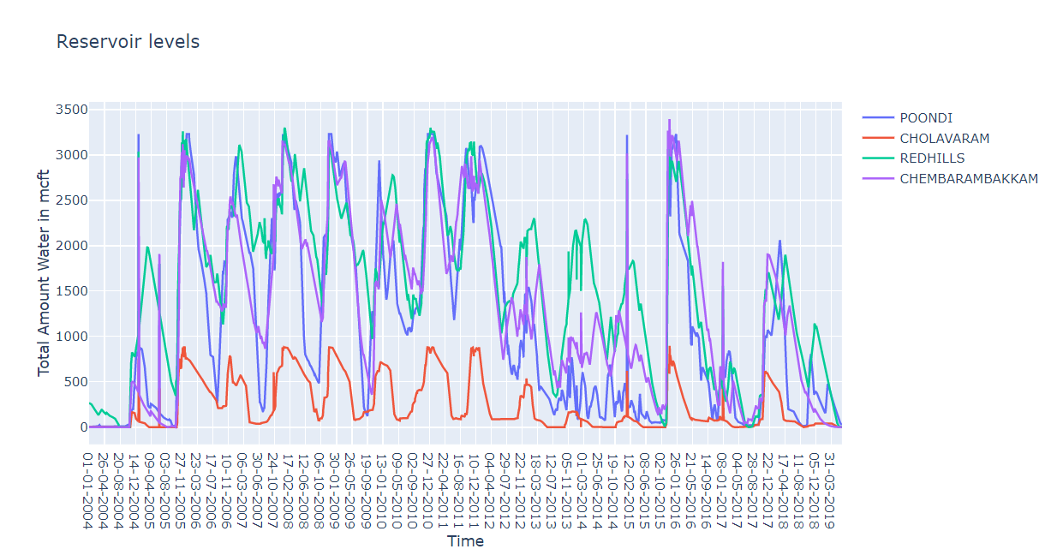

Inferences
- We could clearly see that every year there is a decremental phase and a replenishment phase (mainly during October to December).
- There was a very bad water scarcity phase seen during 2004.
- We can also see a bad phase during 2014-15 but there was to water availability in two reservoirs (Redhills and Chembarambakkam) and so it was a saviour.
- Now coming to recent times, the data shows that there is no water availability in any of the four major reservoirs.

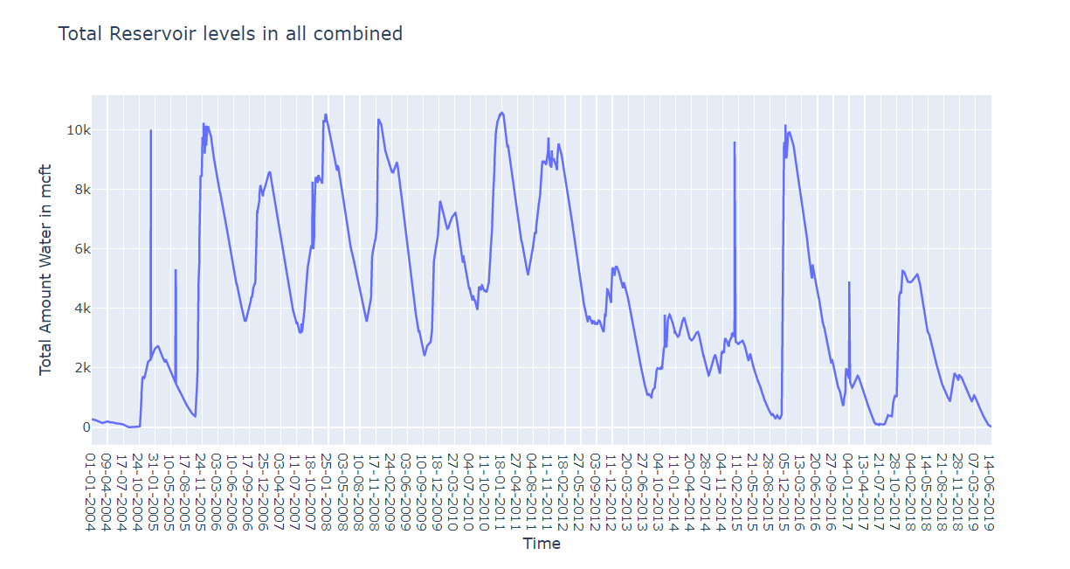

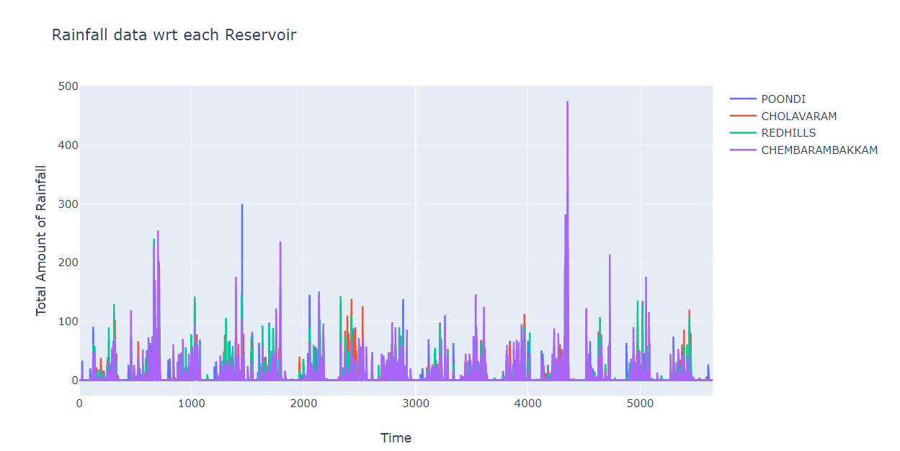

Area plot where each red line shows a division of season in Chennai
This shows that the reservoir level, as expected is highest during the months of September to November (area is greatest)
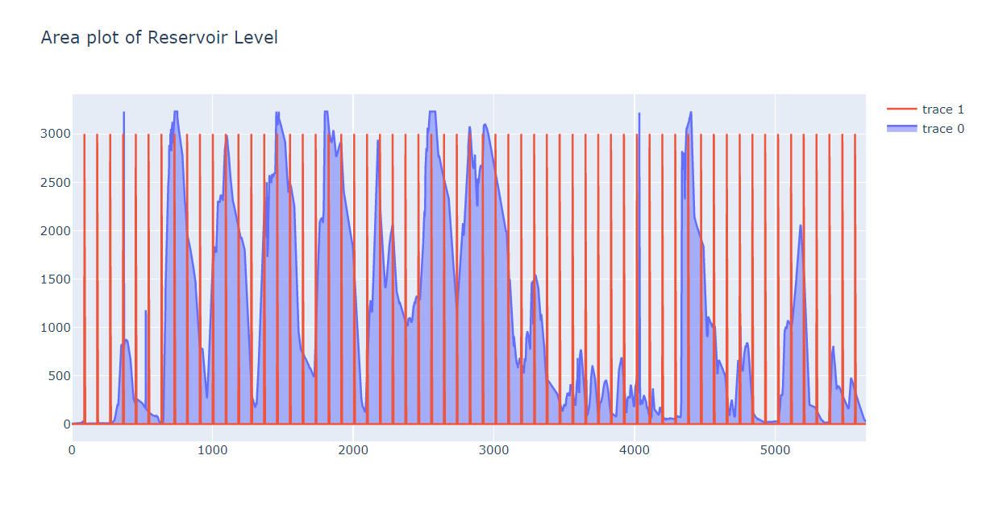
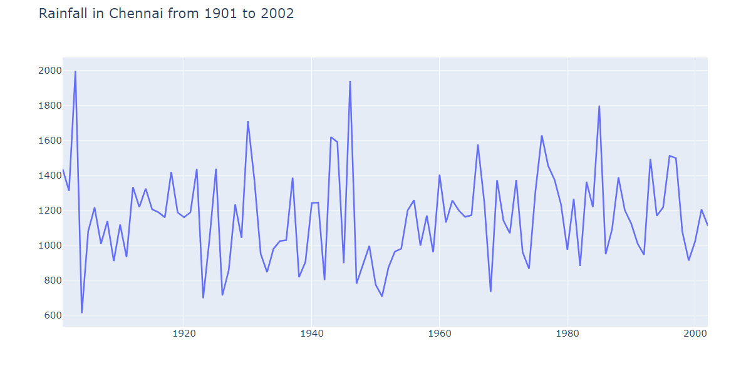

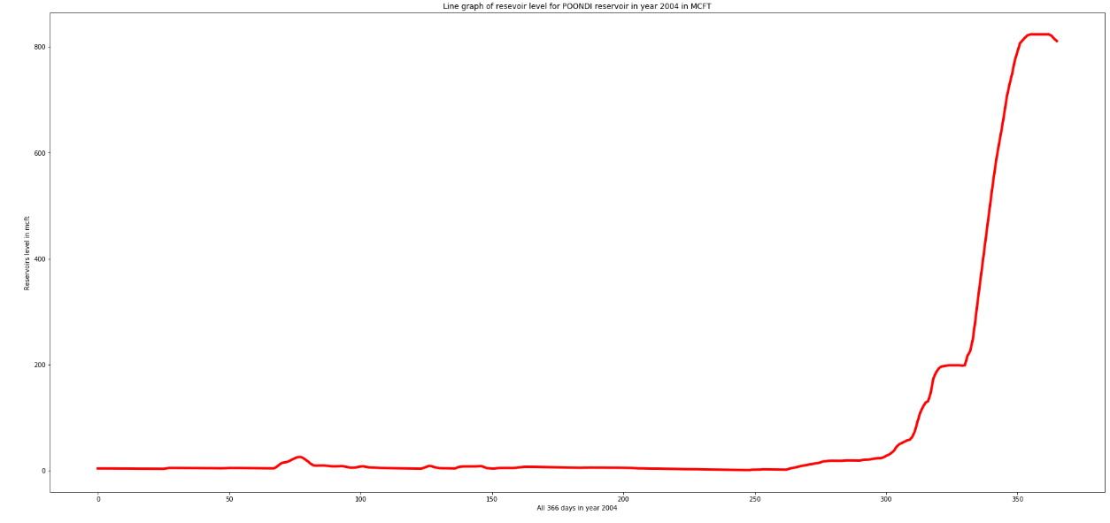
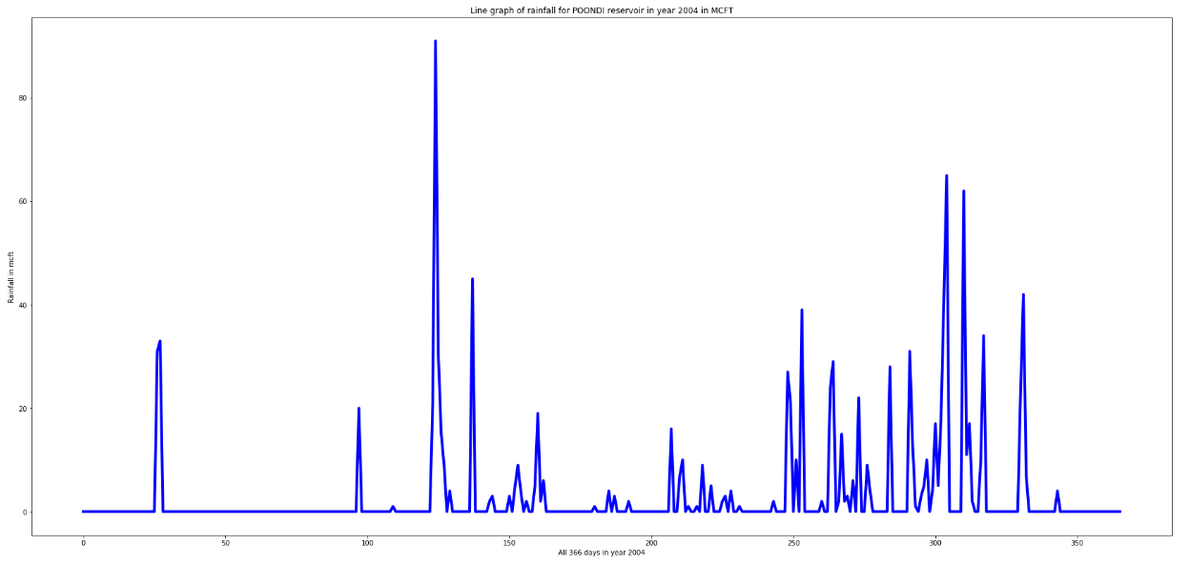
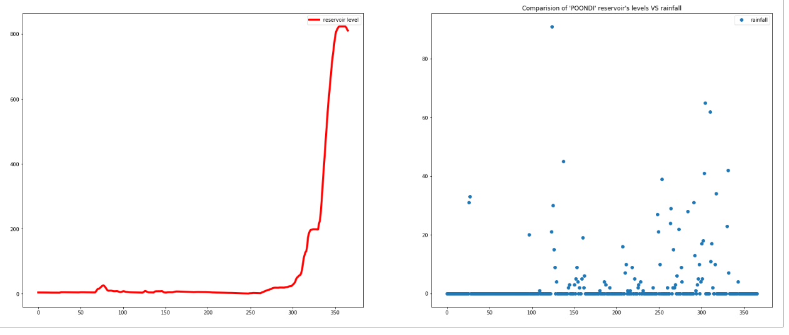

The following are plots of water levels of the POONDI Reservoir through all years 2004-2019
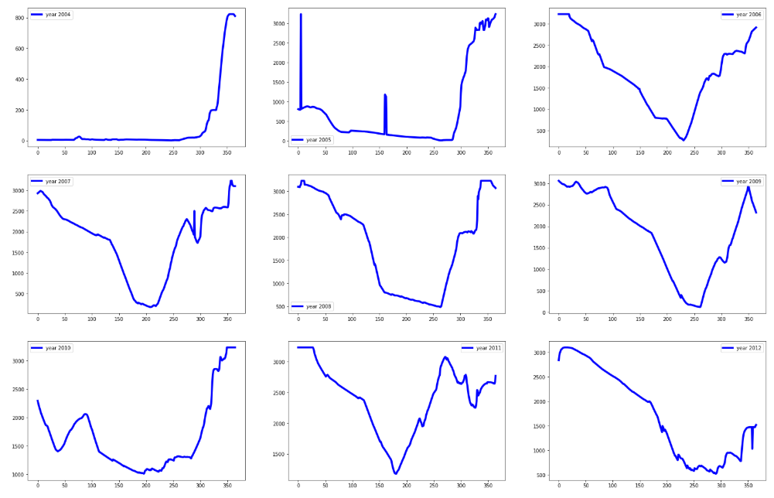
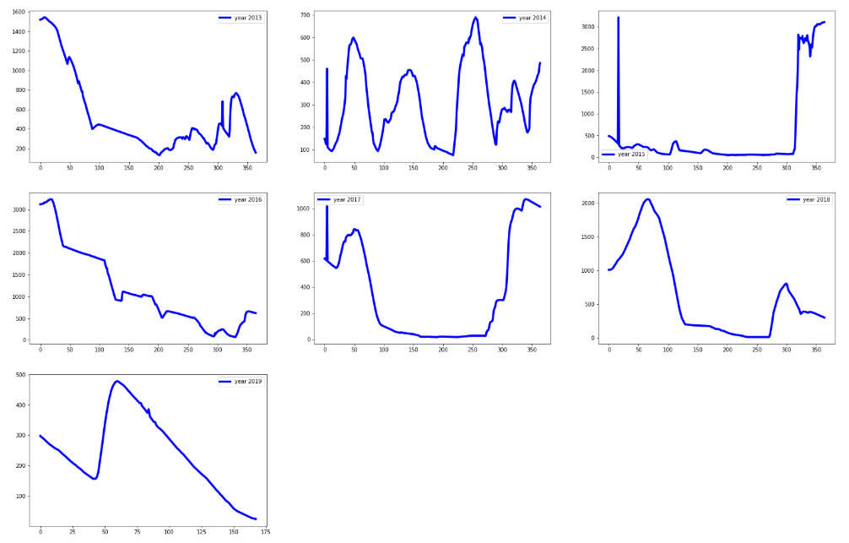
- All the above graphs are of levels of 'POONDI' reservoir but all the graphs do not follow the same behaviour.
- This shows that 'POONDI' reservoir have different water levels throughout the different year.
- Hence, we can say that the reservoir's replenishing life cycle is not year dependent.
- Or, we can say that replenishing cycle of 'POONDI' is not same as we have fixed season time every year.
- As we can see, the water levels are highest during the start and end of the year, the spikes seen in most of the graphs
- The year 2014 shows the greatest deviation with multiple spikes in water level throughout the year. This coincides with the major floods in the year 2014.
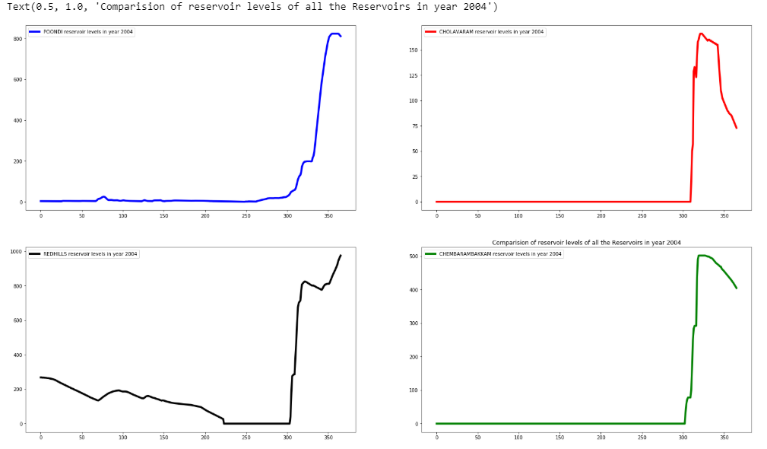
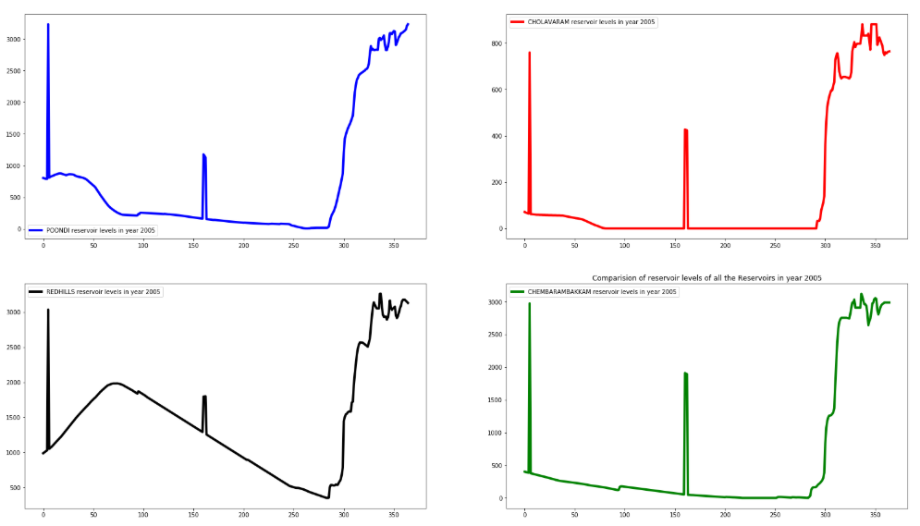
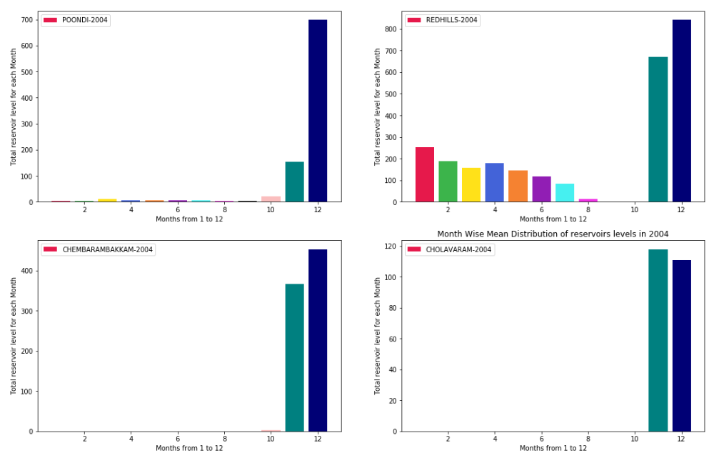
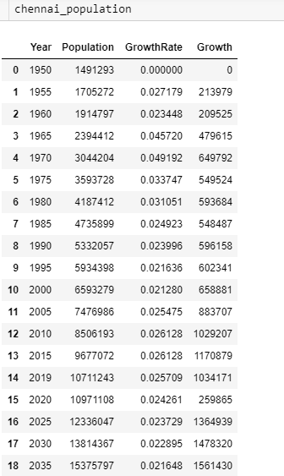
Population Growth
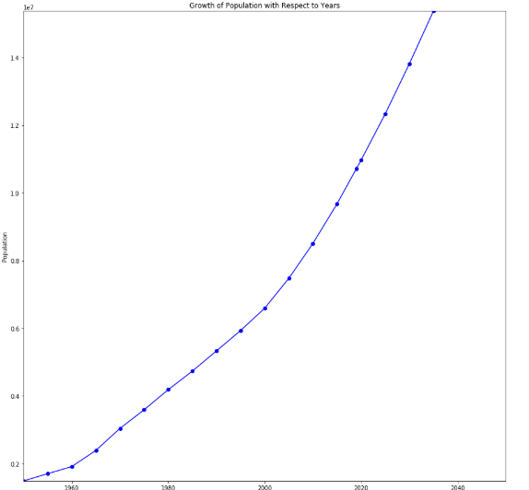
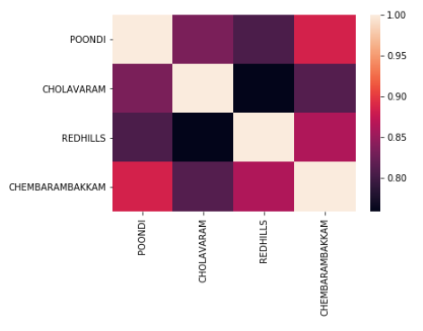
The above correlation matrix shows the correlation between the dams and each other. As can be observed, Chembarakkam and Poondi seem to have more than simply coincidental correlation.
INTERACTIVE PLOT
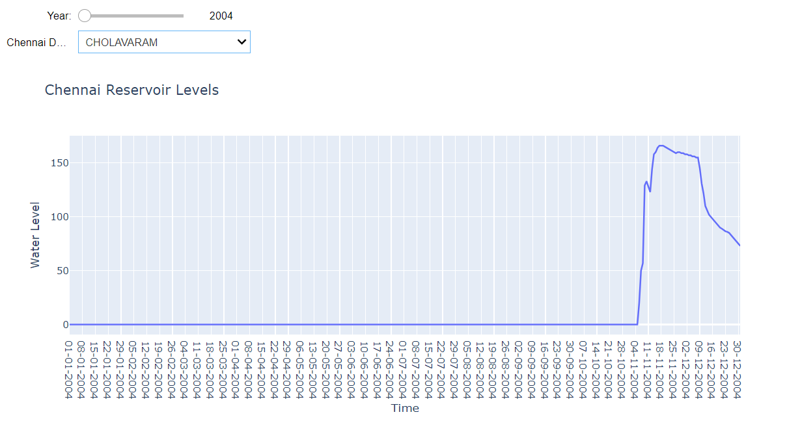
The slider shows the different years.
The drop-down gives the different dams
This provides easy side-by-side interchangeable comparison per year, dam wise.

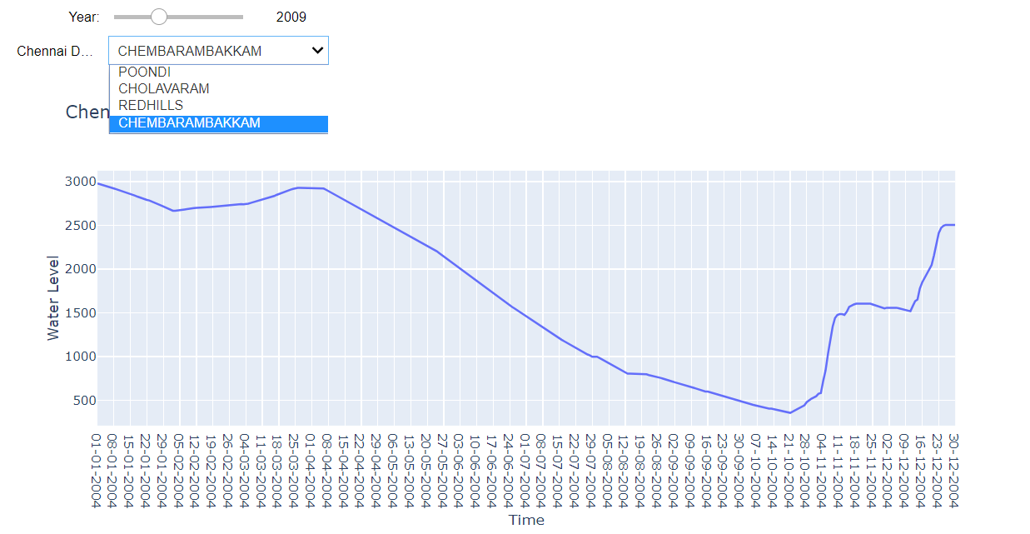

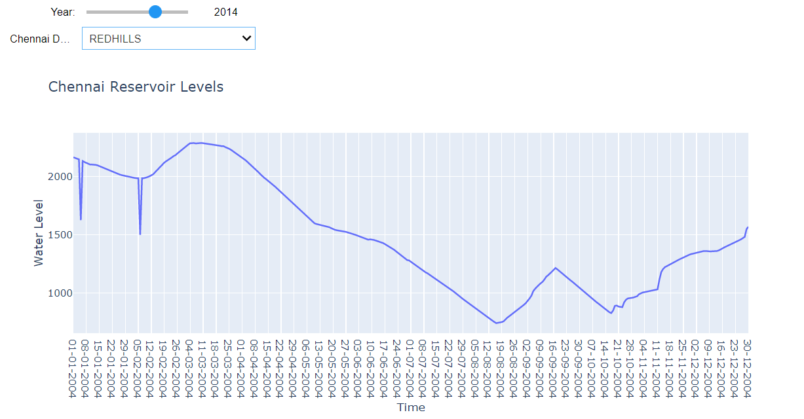

Also can be observe using this easy interactive vis, the year 2014 was indeed an anomaly across all dams.

Prediction of water Level in 4th Dam
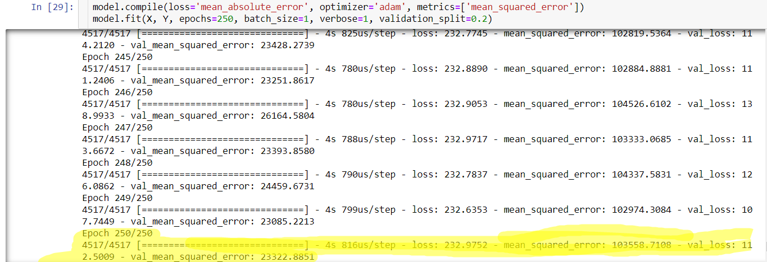

High Error due to:
- Exclusion of Time parameter. No way to account for time properly as a dependency factor.
- No account for external sources of water that could be hindering the connection of the 4 dams (even though they do show high correlation with each other as seen above)
- No account for human activity.

FUTURE WORK

- Ground water was identified as a major factor, but data could not be collected due to cost restraints, future work may include exploring that aspect.
- Rain water harvesting is proposed as a solution, prediction of water levels with a rain water harvesting model may be explored.
- Dynamic dashboards may be implemented for more data.

References
[1].Chennai city water supply system: http://www.shodhganga.inflibnet.ac.in
[2].Chennai government of Tamil Nadu http://www.cmdachennai.gov.in
[3].Chennai Metropolitan Water Supply and Sewerage Board (CMWSSB) in Tamilnadu http://www.chennaimetrowater.gov.in [4].Description of Chennai metropolitan area http:// www.ir.inflibnet.ac.in
[5].Population of Chennai city http://www.census.co.in
[6].G C Maheshwari and B Ravi Kumar Pillai, The water crisis in India: need for a balanced management approach, International Journal of Regulation and Governance.
[7].Suchismita Das and Parag Shil, Panchayati Raj: A Way Out of Drinking Water Crisis in Rural India, Volume : 3 , Issue : 7 , July 2013.
[8].Dr. A. B. Angappapillai, dr. C. K. Muthukumaran, Demand and Supply of water resource in the state of tamil nadu: a descriptive analysis, Asia Pacific Journal of Marketing & Management Review Vol.1 No. 3, November 2012, ISSN 2319-2836. [9].Arunkumar M., Nethaji Mariappan V.E., WATER DEMAND ANALYSIS OF MUNICIPAL WATER SUPPLY USING EPANET SOFTWARE, International Journal on Applied Bioengineering, Vol. 5, No.1, Jaunary 2011.
[10].Jeppiaar , Radhakrishnan R , Manoharan N, Improved Water Management Strategies for Chennai Metropolitan Area, Journal on Design and Manufacturing Technologies, Vol.1, No.1, November 2007

